CURRICULUM​ ​VITAE

​ ​OBJECTIVE

To utilize my skills and abilities in the organization that offers professional growth

while​ ​being​ ​resourceful,​ ​innovative​ ​and​ ​flexible​.

​ ​EDUCATION​ ​QUALIFICATIONS

Qualification

Diploma

in

Mechanical

engineering

Plus​ ​Two

SSLC

Institution

Engineering​ ​Training

Centre​ ​,​ ​Kottayam

Jerusalem​ ​mount​ ​higher

secondary​ ​school

M.G.E.M.H.S.S

(Vakathanam,kottayam)

University

Indian instutino

Of engineering

State​ ​board

State​ ​board

Year

2014

2012

2010

CERTIFICATION​ ​COURSES

➢ ASNT​ ​NDT-​ ​Level​ ​II

I.Ultrasonic​ ​testing

II.

III.

IV.

Radiographic​ ​testing

Magnetic​ ​Particle​ ​testing

Penetrant​ ​testing

➢ Industry​ ​oriented​ ​practical​ ​training​ ​program

I.QA&QC

II.

III.

​ ​ACADEMIC​ ​EXPERIENCE

Welding​ ​Inspection

Piping​ ​&​ ​Pipeline​ ​Engineering

➢ Project ​completed on the topic ​“HYBRID TWO WHEELER WITH FRONT

WHEEL​ ​DRIVE

AREA​ ​OF​ ​INTEREST

➢

➢

➢

➢

Quality​ ​Checking

Piping

Manufacturing

Automobile​ ​field

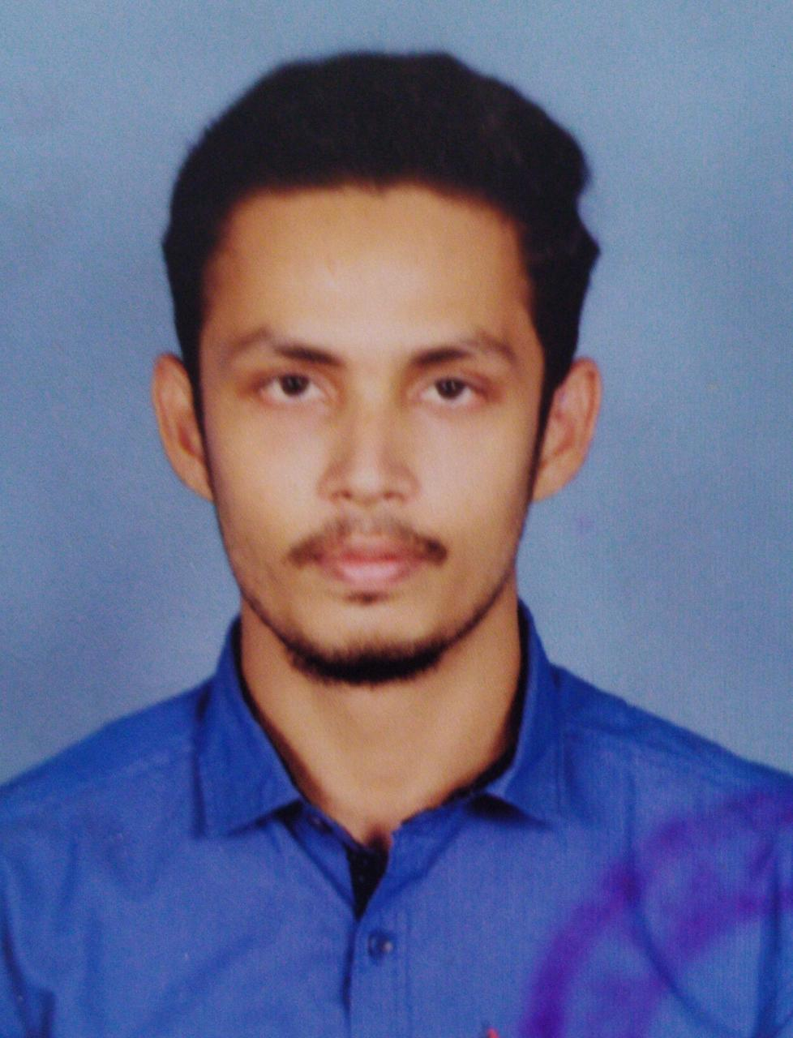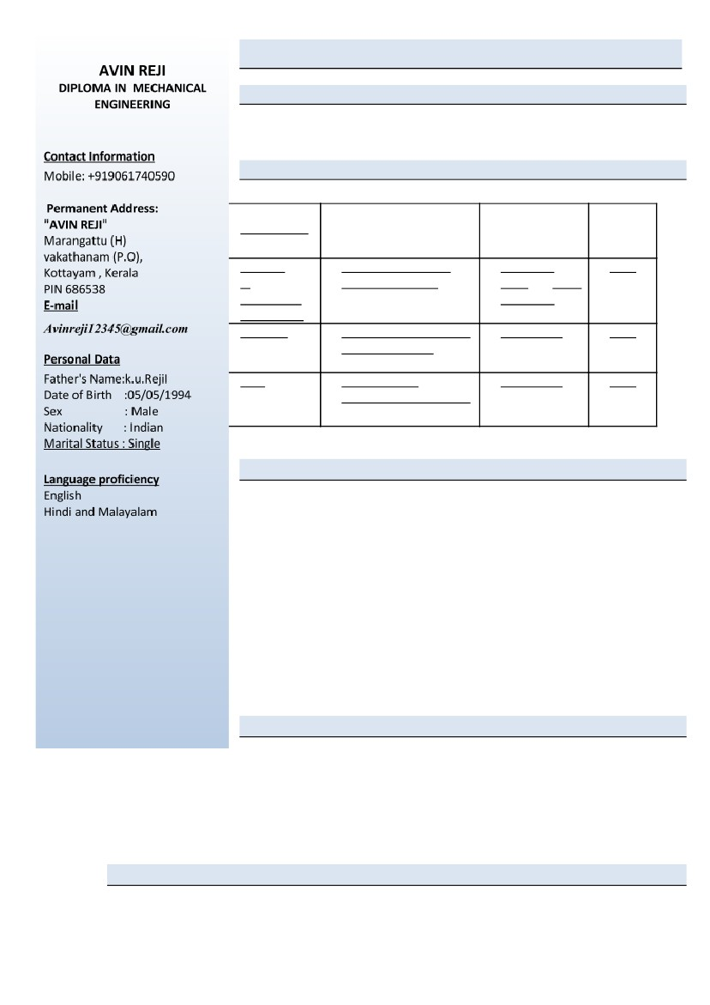

​ ​INDUSTRIAL​ ​VISIT​ ​AND​ ​TRAINING

➢ Industrial​ ​training​ ​at​ ​Common​ ​Facility​ ​Service​ ​Centre.

​ ​ ​ ​PERSONAL​ ​SKILLS

➢

➢

➢

➢

➢

➢

➢

➢

Quick​ ​learner.

Leadership​ ​quality.

Self-driven​ ​and​ ​takes​ ​initiatives.

Integrity​ ​and​ ​commitment.

Ability​ ​to​ ​deal​ ​with​ ​people​ ​diplomatically.

Ability​ ​to​ ​adapt​ ​to​ ​consult​ ​evolution​ ​and​ ​change.

Fluently​ ​speaks​ ​English,Malayalam&Tamil

Is​ ​sincere​ ​at​ ​my​ ​job

​ ​Experience

\*​Work​ ​as​ ​services​ ​advisor​ ​in​ ​Honda​ ​two​ ​wheels​ ​showroom​ ​from​ ​22nd September 2015 to 30th april 2019

​ ​ ​ ​DECLARATION

I do hereby declare that all the information mentioned above is correct to the best of my

knowledge.

Place:​ ​ ​KOTTAYAM

​ ​ ​REFERENCE

​ ​ ​ ​ ​ ​ ​Prof.​ ​Sonu​ ​Krishnan

​ ​ ​ ​ ​ ​ ​Dept.​ ​of​ ​ME,

​ ​ ​ ​ ​ ​ ​Engineering​ ​Training​ ​Centre,

​ ​ ​ ​ ​ ​ ​ ​ ​Mob:​ ​+91​ ​9048449752.